

**ISM 6217 – Database Management Systems**

**Fall 2017**

**Class Assignment 5**

**5 points**

**Task: Adding Constraints and Table rows insertion**

1. Complete the hands-on exercises 5, 6, 7 and 8 from Chapter 4,page 138 of the textbook. Paste the SQL and results. Verify the constraints by querying the user_constraints table and paste screen shot of those results. (3 points)

**Answer to Question 5**

CREATE TABLE Book_Stores (Store_ID Number(8) CONSTRAINT stid_pk PRIMARY KEY, Name Varchar2(30) CONSTRAINT name_bb NOT NULL UNIQUE, Contact Varchar2(30), Rep_ID Varchar2(5));

SELECT CONSTRAINT_NAME , CONSTRAINT_TYPE FROM USER_CONSTRAINTS WHERE TABLE_NAME = ‘BOOK_STORES’;

Desc book_stores;

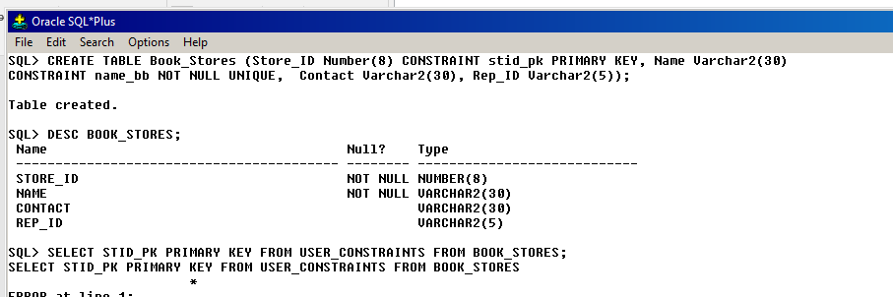

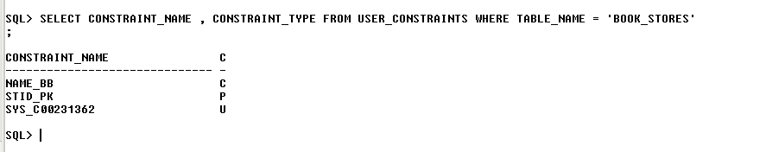

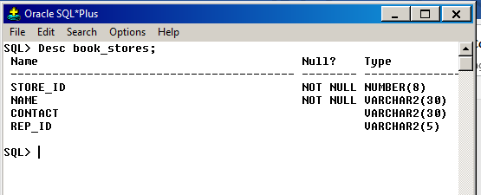

**QUESTION 1 - CREATING STORE_REPS TABLE (NEEDED TO ANS QUESTION 6)**

CREATE TABLE STORE_REPS (REP_ID NUMBER(5) CONSTRAINT stREP_pk PRIMARY KEY, LAST VARCHAR2(15), FIRST VARCHAR2(10), COMM CHAR(1));

SELECT CONSTRAINT_NAME , CONSTRAINT_TYPE FROM USER_CONSTRAINTS WHERE TABLE_NAME = ‘STORE_REPS’;

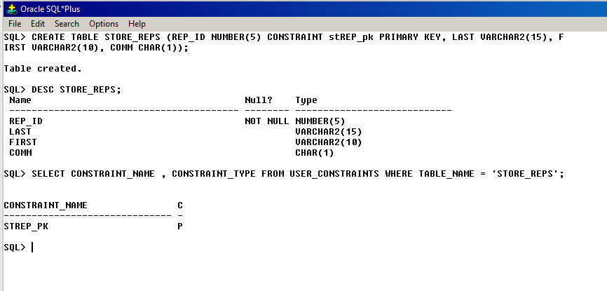

**Answer to Question 6**

ALTER TABLE BOOK_STORES ADD CONSTRAINT REPID_FK FOREIGN KEY (REP_id) REFERENCES STORE_REPS (REP_id);

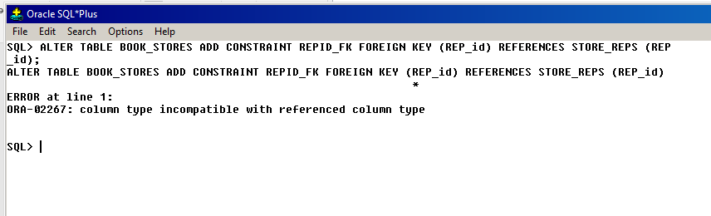

YES, ERROR CAUSED WHEN ADDING CONSTRAINT

MODIFICATION – ALTERED STORE_REPS REP_id CHARACTER TYPE TO THAT OF BOOK_STORES – VARCHAR2(5) because varchar data type takes alphanumeric.

Alter table STORE_REPS modify (rEP_id VarChar2(5)); --- > no ERROR THEN

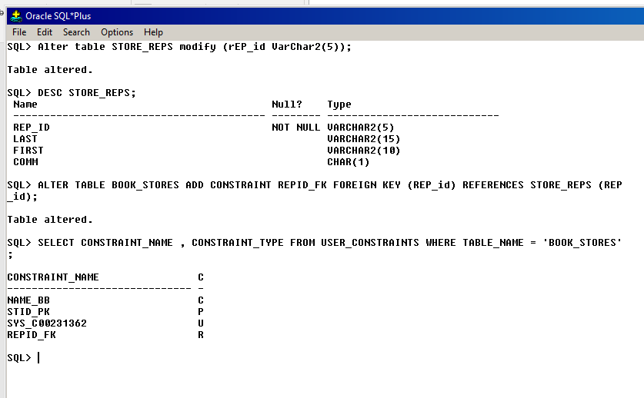

**Answer to Question 7**

ALTER TABLE STORE_REPS DROP PRIMARY KEY CASCADE;

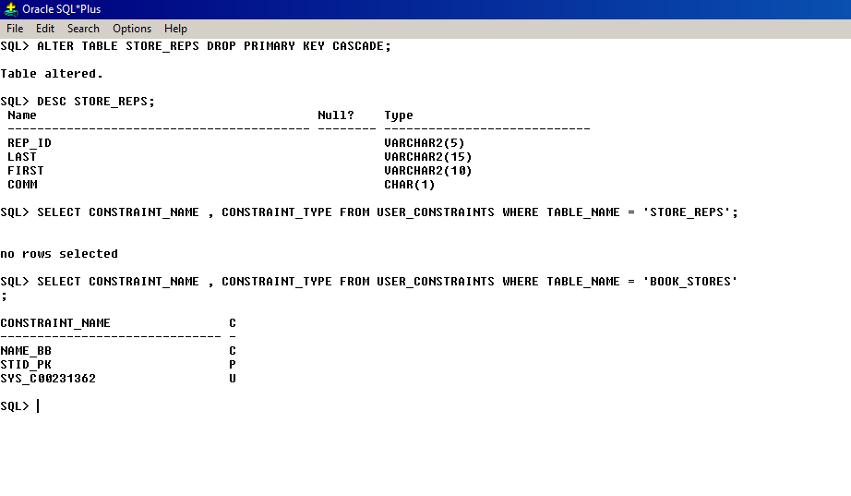

**Answer to Question 8**

STEP 1- CREATING TABLE AND ADDING PRIMARY KEY

CREATE TABLE REP_CONTRACTS (REP_id NUMBER(5), sTORE_iD NUMBER(8), QUARTER CHAR(3) CONSTRAINT REPCONT_pk PRIMARY KEY, NAME NUMBER(5));

Desc rep_contracts;

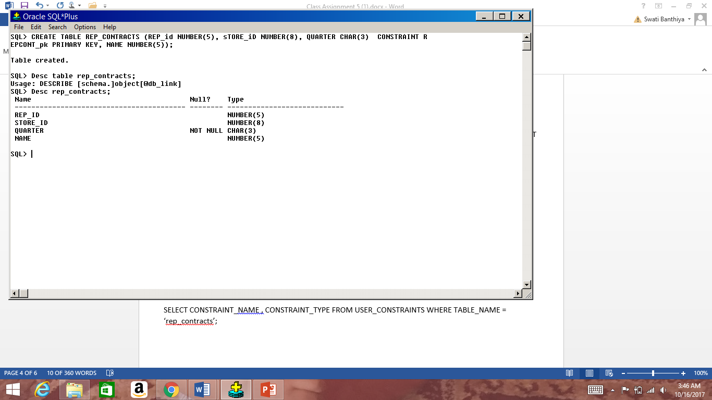

sTEP 2- ADDING FOREIGN KEY STORE_id AND REP_id

(FOR WHICH ALTERATION TO CHARACTER TYPE IN REP_id IN STORE_REPS IS REQUIRED- TO NUMBER(5) & ALTER TABLE STORE_REPS ADD CONSTRAINT STREP_PK PRIMARY KEY (REP_id); - PRIMARY KEY WAS DELETED IN QUES 7)

Alter table STORE_REPS modify (rEP_id NUMBER(5)); (WAS CHANGED TO VARCHAR2(5) IN QUE.6)

ALTER TABLE REP_CONTRACTS ADD CONSTRAINT REPCONT_FK FOREIGN KEY (REP_id) REFERENCES STORE_REPS (REP_id) ON DELETE CASCADE;

ALTER TABLE REP_CONTRACTS ADD CONSTRAINT StoreId_FK FOREIGN KEY (STORE_id) REFERENCES Book_stores (store_id) ON DELETE CASCADE;

SELECT CONSTRAINT_NAME , CONSTRAINT_TYPE FROM USER_CONSTRAINTS WHERE TABLE_NAME = ‘REP_CONTRACTS’;

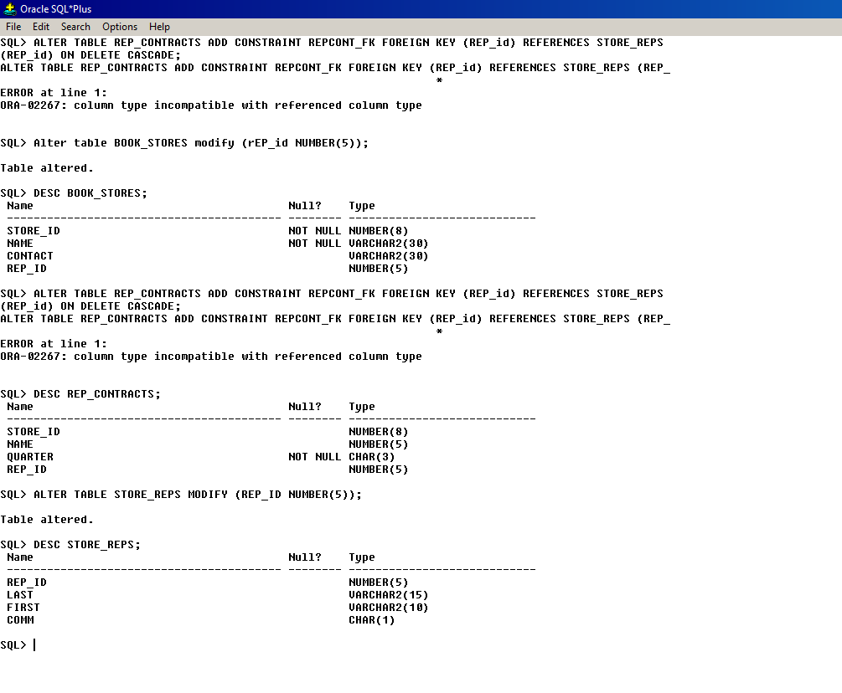

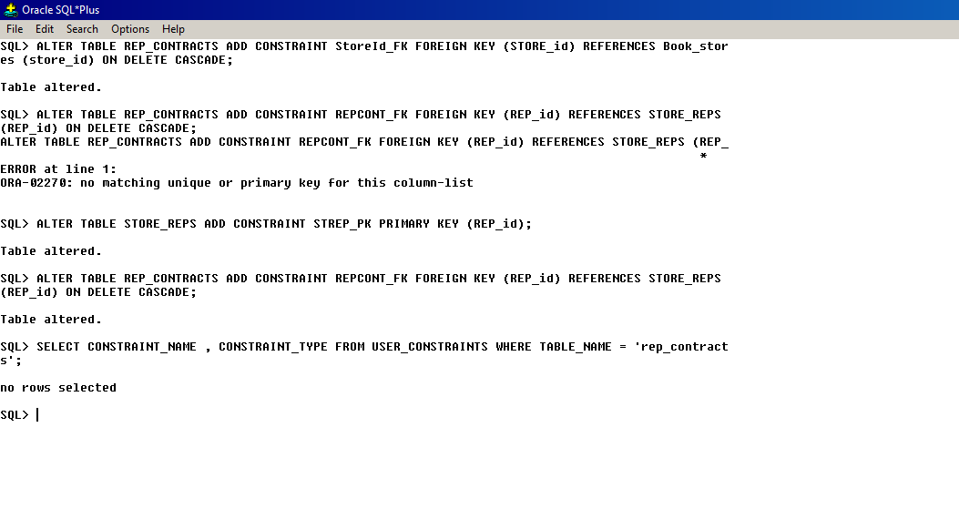

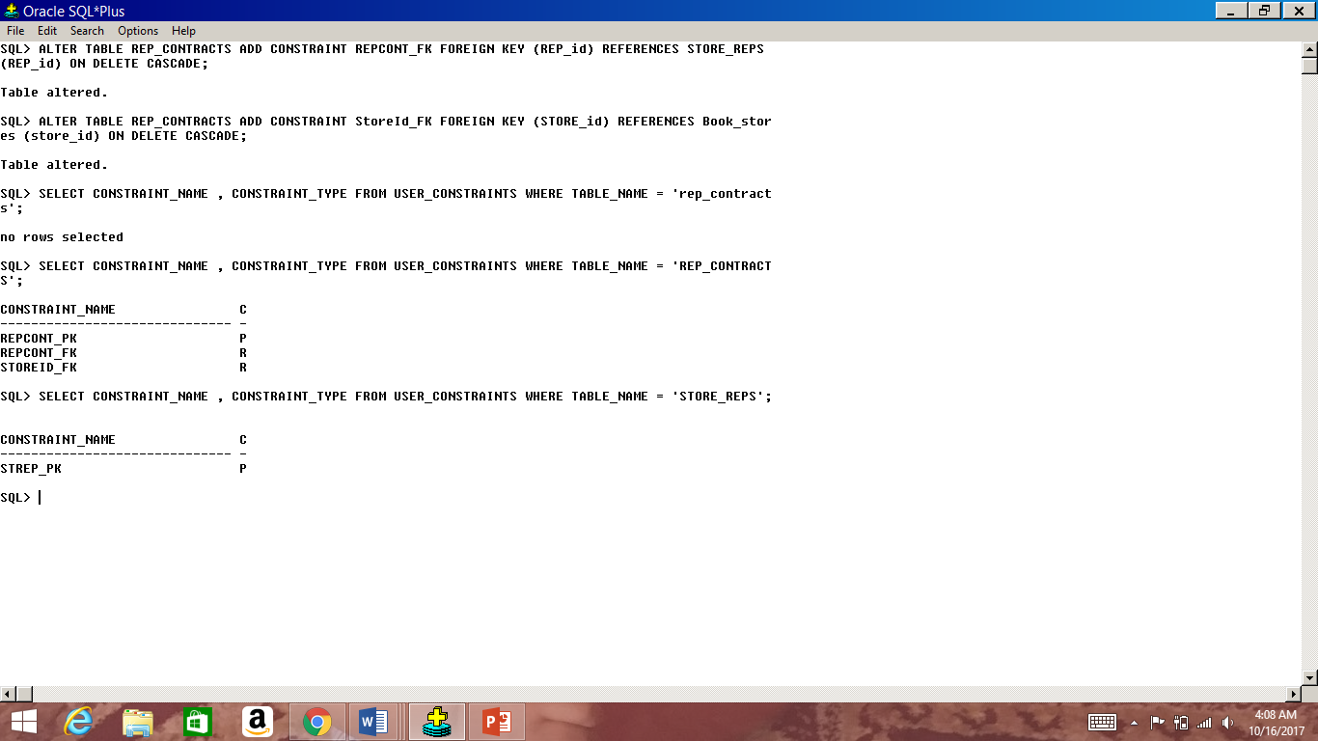

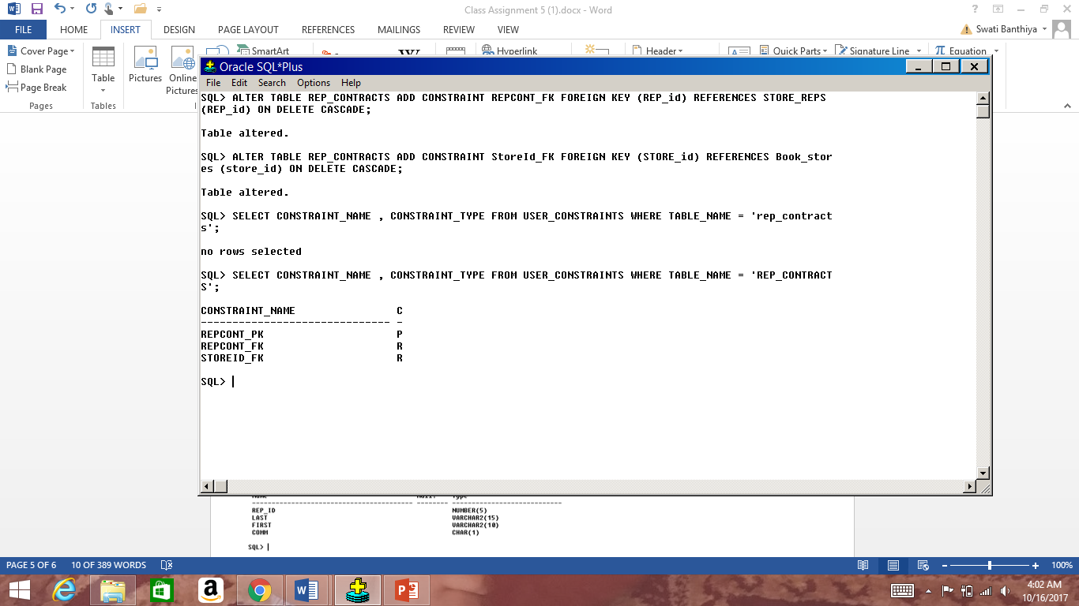

1. Add/Insert one row to any 3 of the eight tables in JustLee database (created in assignment 3). You can query each one first and see what type of data is there then add a similar data row. Paste SQL and Results. (1 point) --- EACH TABLE BEFORE ADDING ROW AND ADDING ROW SNAPSHOT IS GIVEN

TABLE 1 - INSERT INTO AUTHOR VALUES(‘S109’, ‘BANTHIYA’,’SWATI’);

BEFORE

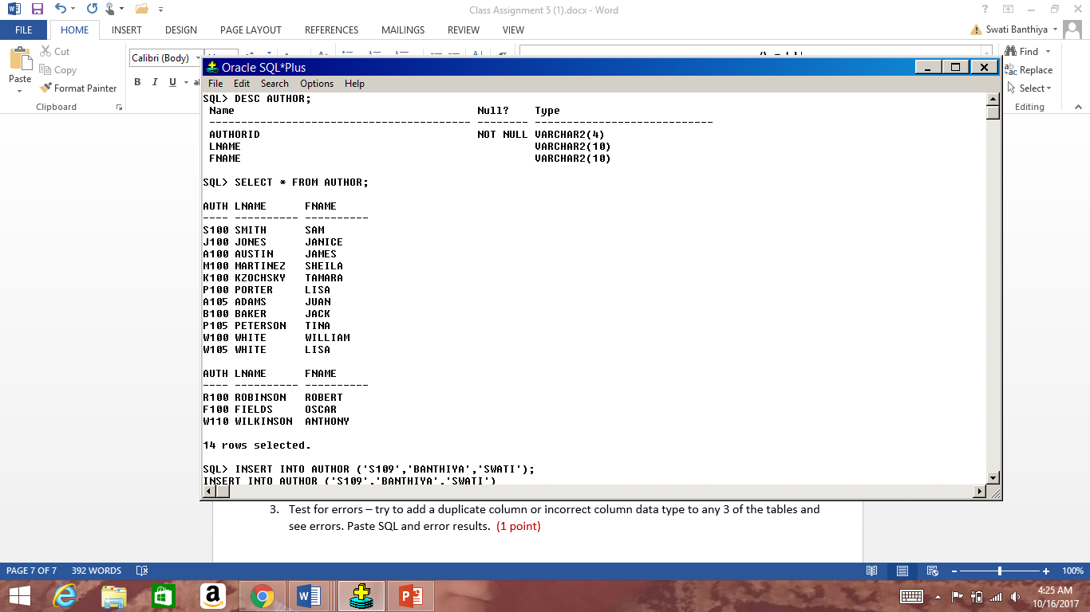

AFTER

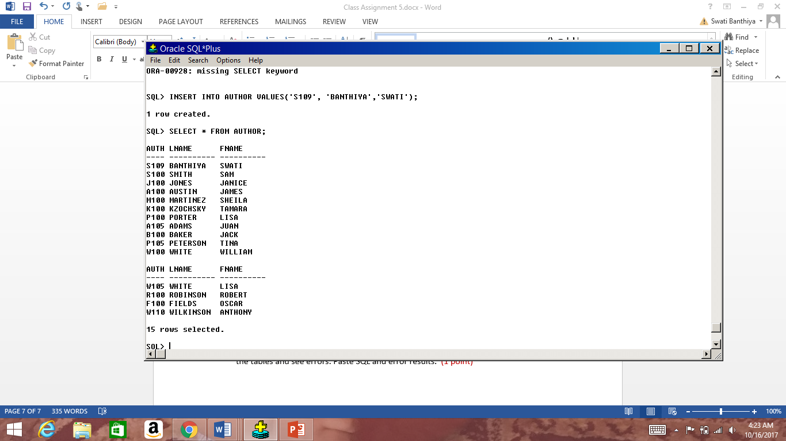

TABLE 2 - INSERT INTO CUSTOMERS VALUES(‘1021’, ‘JAIN’,’PARTH’,’P.O. BOX 211’,’BOCA RATON’,’FL’,’33496’,NULL,’SE’);

BEFORE

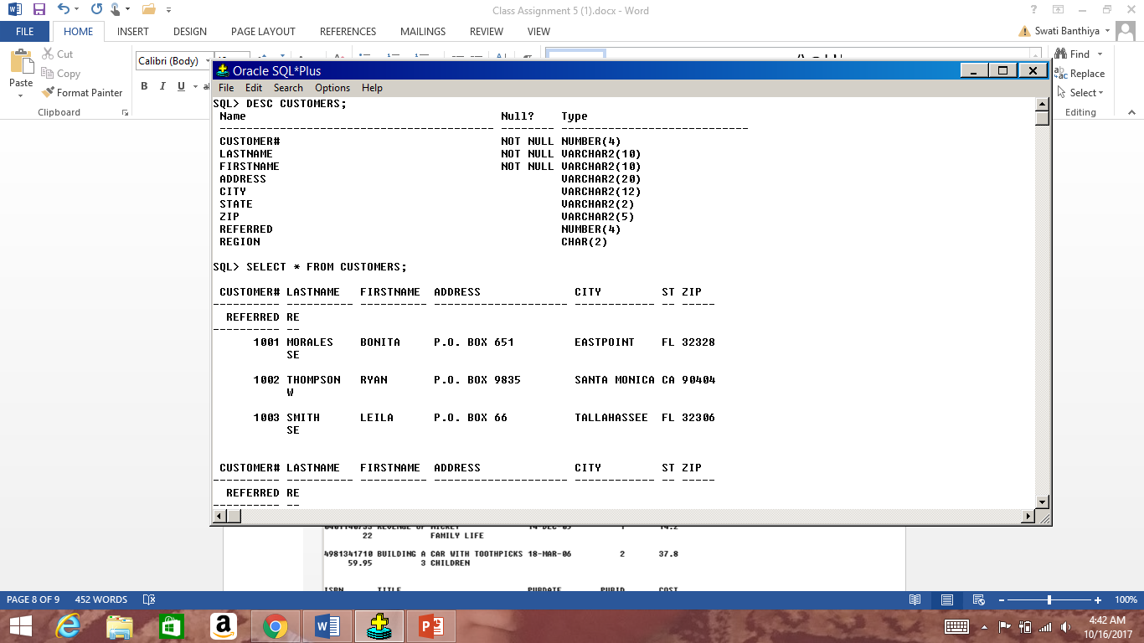

20 ROWS SELECTED

AFTER

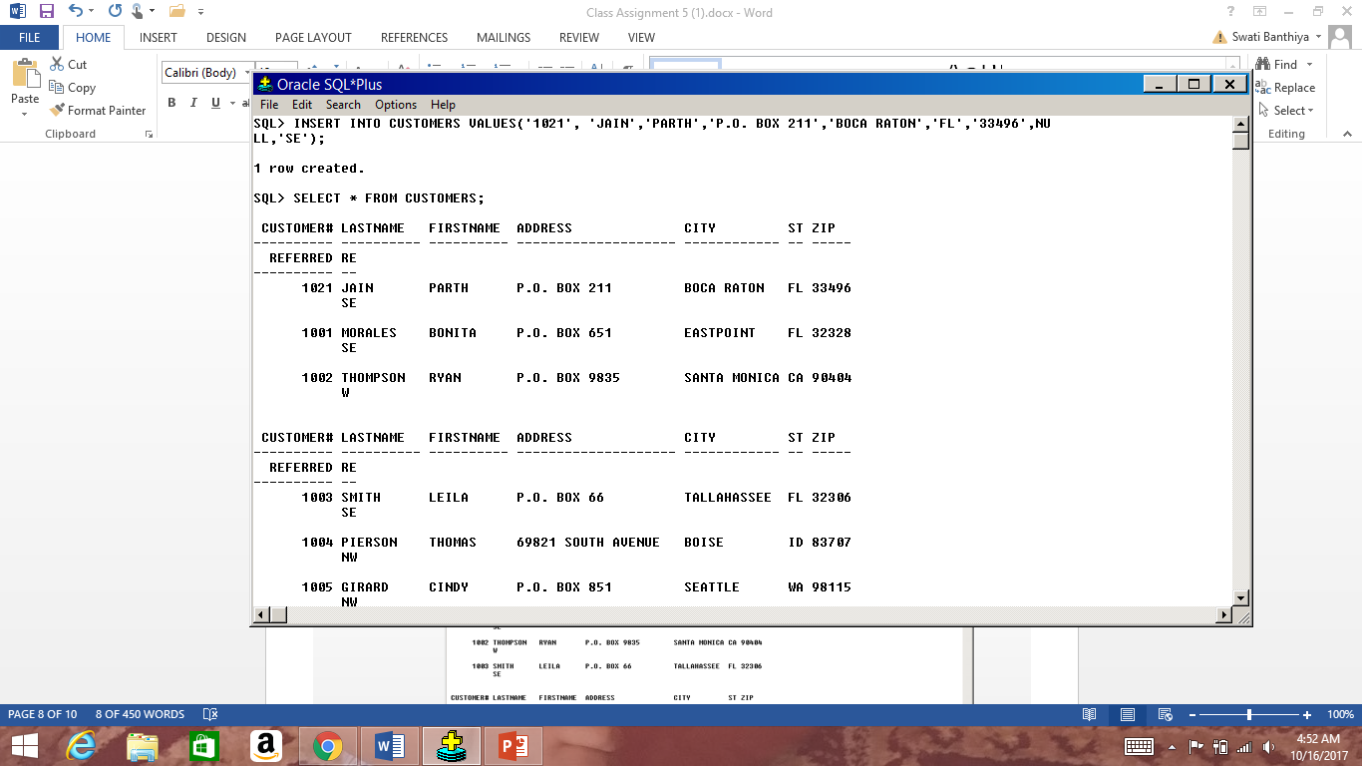

21 ROWS SELECTED

TABLE 3 - INSERT INTO PROMOTION VALUES(‘HIGHLIGHTER’, 13,23);

BEFORE

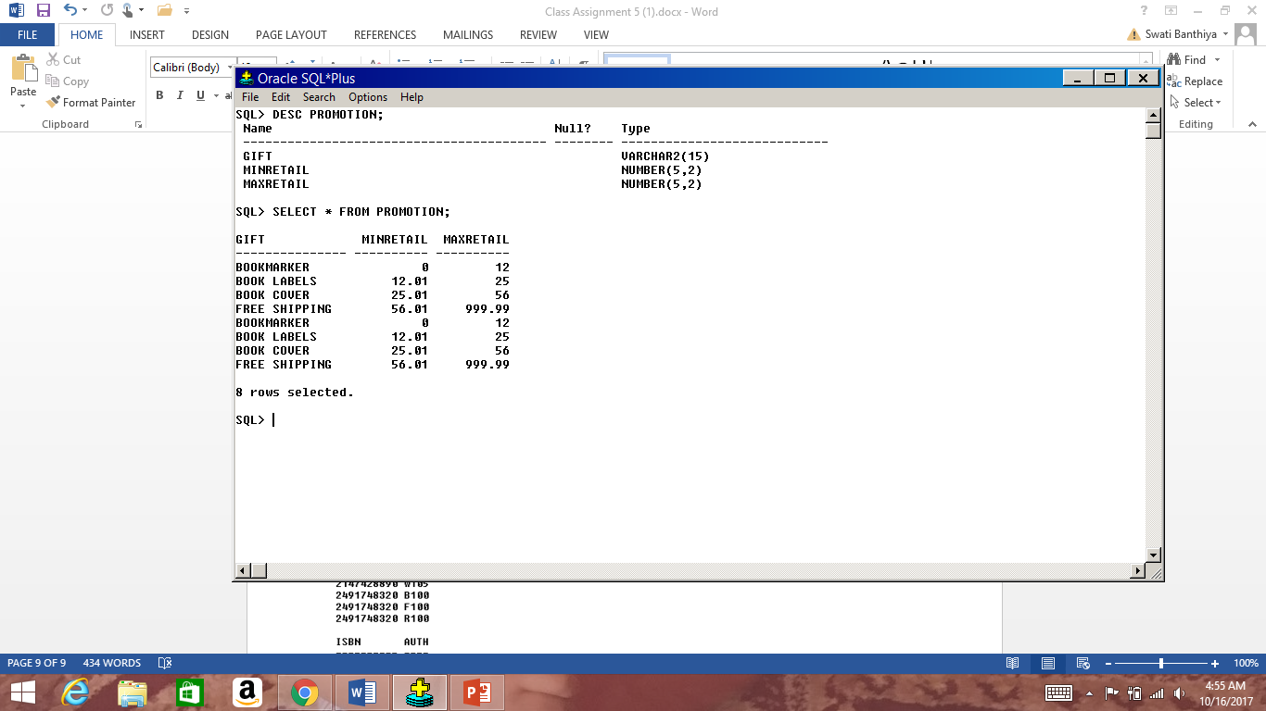

AFTER

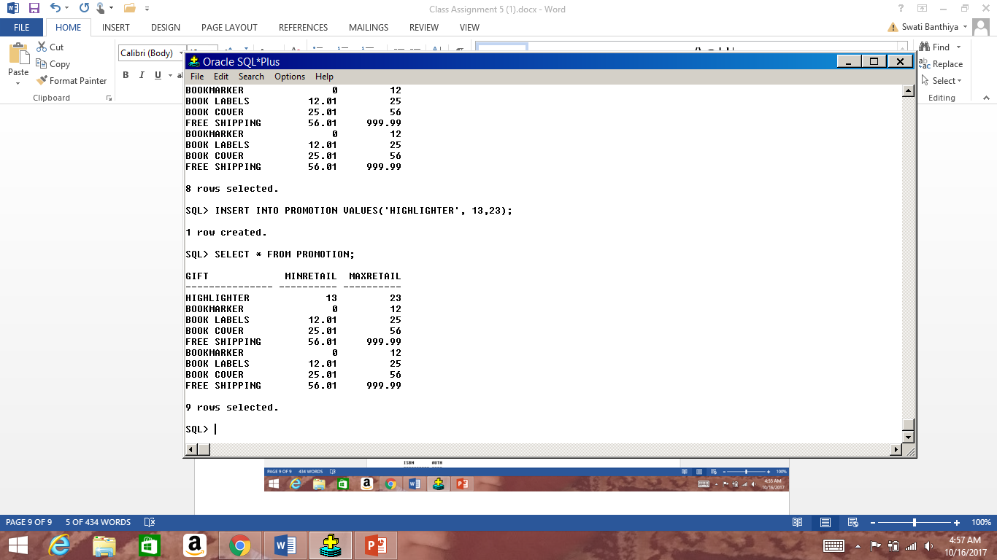

1. Test for errors – try to add a duplicate column or incorrect column data type to any 3 of the tables and see errors. Paste SQL and error results. (1 point)

**ANSWER TO QUESTION 3 (SAME TABLES USED AS IN QUESTION 2)**

**DUPLICATE COLUMN IN AUTHOR TABLE –only 3 columns in original**

INSERT INTO AUTHOR VALUES(‘S111’, ‘BAN’,’SW’, ‘BCC’);

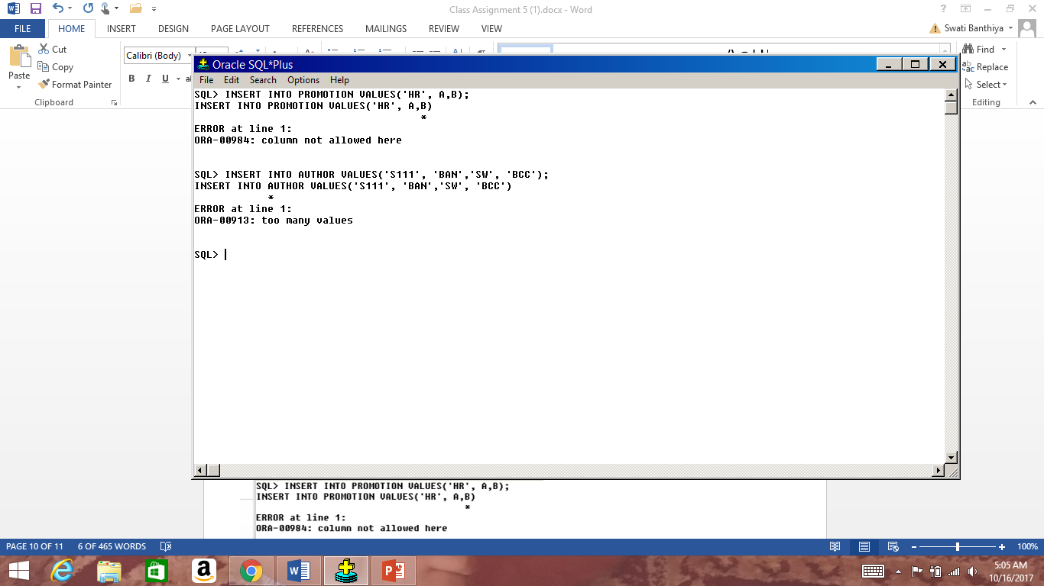

**INCORRECT COLUMN DATA TYPE TO PROMOTION TABLE – last 2 columns are number in original**

INSERT INTO PROMOTION VALUES(‘HR’, A,B);

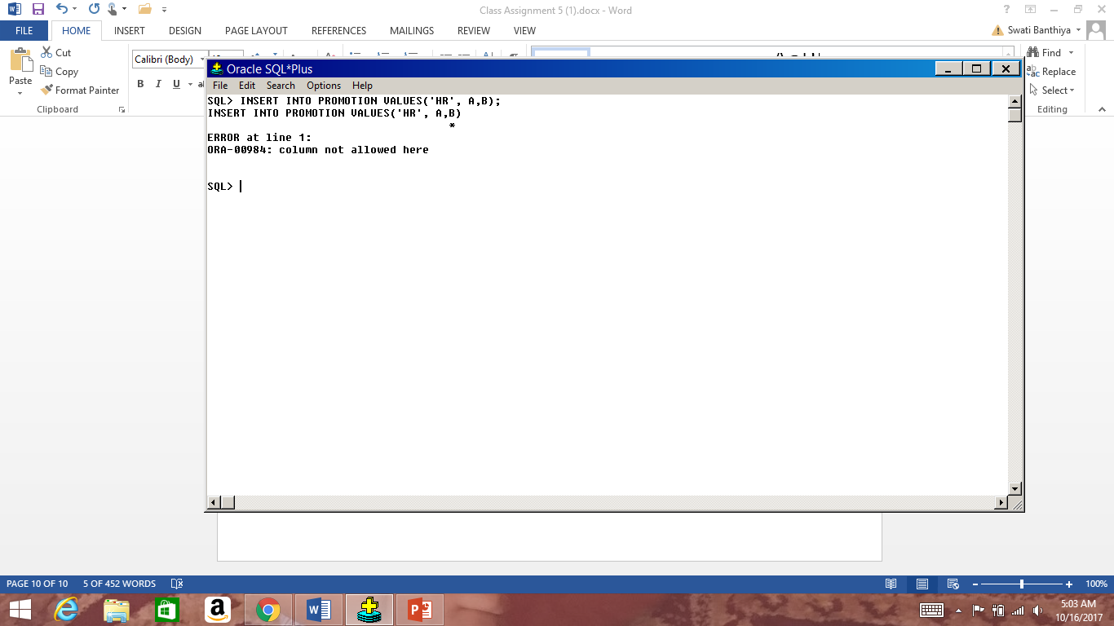

**INCORRECT COLUMN DATA TYPE TO CUSTOMER TABLE – customer no is number in original**

INSERT INTO CUSTOMERS VALUES(abc, ‘JA’,’PA’,’P.O. BOX 211’,’BOCA RATON’,’FL’,’33496’,NULL,’SE’);

